draft - draft - draft - draft - draft -
CA*net 4 LightPath
Fault Reporting & Escalation Procedures

draft - draft - draft - draft - draft - draft - draft - draft - draft -
Version 0.1
20 September 2005

- Introduction

  - Purpose of the document

This document describes the Fault Management system in place for supporting CA*net 4 LightPaths. It outlines the specific procedures for reporting troubles on CA*net 4 LightPaths from an End-User perspective.

This document is to be considered work in progress. It is periodically updated as the CA*net 4 infrastrucure and services are modified, and as CANARIE NOC and End-User experiences evolve into engineering best practices.

  - Organization of the document

Section 2 of this document presents definitions for words used throughout the document. Section 3 briefly describes the CA*net 4 architecture and services, and associated Service Level Agreement (SLA). Section 4 outlines fault detection, reporting and escalation procedures and section 5 provides some insight into the fault confirmation, troubleshooting, and service restoral processes followed by the CA*net 4 NOC in response to a fault.

Annex A describes the various CA*net 4 service offerings, annex B illustrates the CA*net 4 network topology and annex C lists various diagnostics available to the CA*net 4 NOC.

Appendices describing the Fault Management Process for specific distributed or virtual organisations follow.

  - References

ITU-T Recommendation Y.1311 (03/2002)

- Definitions

  - Fault Management

The set of functions carried out by the LightPath Service Provider, some in conjunction with the End-User, in order to detect, report, confirm, troubleshoot and restore LightPath Services.

  - LightPath Service

A LightPath is a dedicated point-point communication channel providing effective guaranteed bandwidth. Within the CA*net 4 infrastructure, LightPath Services are presented to End-Users over either a GbE, 10GbE or SONET interface and implemented over SONET technology. For any given end-end LightPath Service to be provisioned, resources of one or more LightPath Service Providers, and of two End-Users are required. In the case where more than one LightPath Service Provider is involved in the end-end provisioning of a LightPath, one of the Service Providers acts as the end-end LightPath Service Provider and main point of contact in regards to the end-end LightPath Fault Management.

  - LightPath Service Demarcation Point

The LightPath Service Demarcation Point is the dividing line between the LightPath Service Provider(s) and the End-Users, regarding Fault Management responsibility.

The OXC which hosts this interface is the active provider edge (PE). Moving towards the end user, the first active device connected to the PE by a pair of dark fibres and/or WDM equipment is referred to as the active customer edge (CE) device. The Demarcation Point is the CE port which interconnects to a PE port, unless the fibre connected the CE and PE equipment is owned or managed by the same entity that manages the CE equipment. In this case the demarcation point is the PE port.

PE
PE
LightPath Service Provider(s)
CE
CE

  - LightPath Service Provider

The LightPath Service Provider is the organization that provides the PE interface facing the CE. This is the only point at which any diagnostics and troubleshooting can be done on the LightPath. For example, if a user has dedicated fiber that terminates on CA*net 4 PE off campus then CANARIE is the LightPath Service Provider.

From the End-User perspective, is the entity managing the PE and LightPath supporting infrastructure. Where end-end LightPaths are provisioned across multiple domains, the LightPath Service Provider is the usually the Service Provider which coordinates the end-end engineering of the LightPath in response to a LightPath request. This Service Provider acts as the single point of contact for end-end LightPath Fault Management. This includes coordination of Fault Management across LightPath domains.

  - End-User

From the Service Provider perspective, the End-User is the entity managing the active CE device. The End-User may be the application-layer end-user, or could be an entity providing the application-layer end-user networking support, such as the campus IT / networking support group, or an ORAN.

  - SONET

Time-division multiplexing protocol used in CA*net 4 for aggregating / deaggregating independent fixed capacity communications channels. The [high-order] base channel size is an STS-1, which corresponds to ~51.84 Mbps of capacity. This aggregation / deaggregation function is referred to as SONET line termination and is one of three central tasks performed by the CA*net 4 OXCs.

  - OXC

Acronym for optical cross-connect. Also referred to as OEO switch, or SONET/SDH switch. Is the device which performs the SONET line termination of the CA*net 4 10G wavelengths. Other functions performed by the OXCs are adaptation of GbE client interface data into SONET channels and the cross-connecting of same-size channels.

  - ORAN / GigaPoP Operator

Acronym for optical regional advanced network. A provincial / territorial based organisation who's mission includes supporting the intra-provincial / territorial and metro-area networking needs of its research and education organisation constituency. Each ORAN operates at least one GigaPoP, providing connectivity to the CA*net 4 IP backbone.

  - WDM

Acronym for wave division multiplexing. A frequency-division multiplexing technique used to aggregate / deaggregate multiple independent fixed capacity communication channels over a single fibre pair. In the CA*net 4 infrastructure domain, coarse WDM (CWDM) is used in many local loops to interconnect PE and CE GbE interfaces. Dense WDM (DWDM) is used by the CANARIE service providers to channel 10Gbps wavelengths to CA*net 4 OXCs.

  - GbE and 10GbE

Acronym for Gigabit Ethernet and 10x Gigabit Ethernet, respectively. Widely used data link layer protocol running at 1000 Mbps and 10,000 Mbps respectively. 10GbE is also specified as 10GbE LAN Phy or 10GBase-R.

  - UCLP software

Acronym for User-Controlled LightPath. Is a web service-based network provisioning tool for End-Users, specified by CANARIE and implemented by various organisations.

- CA*net 4 Architecture, Services, and Service Level Agreement

  - CA*net 4 Architecture and Services

CA*net 4 is a high performance data network infrastructure for the Canadian research and higher education communities, providing an IP backbone network service to the Canadian ORANs, as well as LightPath services to Canadian and international researchers.

The core of the CA*net 4 layer-1 transport infrastructure is made up of point-point SONET framed OC-192 wavelengths from various 10 Gbps DWDM carriers and of CA*net 4 OXCs located in CA*net 4 Points of Presence. See Annex B for a high level illustration of the CA*net 4 infrastructure.

CA*net 4 LightPath Services include point-point SONET OC-x , 10GbE*, and full- and sub-rate* GbE. Full rate GbE is implemented by mapping a GbE port to an STS-24 channel (~1244 Mbps). GbE mapped to smaller sized channels (STS-1, 3, 6, 9, and 12) provide for sub-rate GbE services. See Annex A for the full listing and description of CA*net 4 LightPath Services.

  - CA*net 4 Service Level

CA*net 4 services are provided without SLA, i.e. on a best-effort basis. However a CA*net 4 NOC is equipped to respond to CA*net 4 Service faults and in case of emergency makes available an on-call NOC engineer on a 365 day / 24 hour basis.

The most common CA*net 4 network fault sources are fibre cuts and CANARIE service provider wavelength transport equipment failures. The service level promised CANARIE by its wavelength providers in the event of such failures is a repair response commensurate with the responses provided other commercial clients. This means that repair and restoral are normally effected within 4 hours of notification. In most cases fault detection by the carrier occurs before CANARIE notification to its wavelength service provider as a fibre cut or DWDM tranpsort failure will normally disrupt many carrier 10 Gbps wavelengths and affect many customers and internal and external wavelength provider services.

For LightPath Service based applications, fibre path redundancy is the responsibility of the End-User. It is built-in to the design for the CA*net 4 IP backbone network.

  - CA*net 4 Network Operations Centre (NOC)

The CA*net 4 NOC is a group within CANARIE responsible for the day-to-day operational management of the network including Fault Management of all services provisioned over CA*net 4. The CA*net 4 NOC is also responsible for network change management engineering and implementation.

- LightPath Service Fault Management Process

  - Detection

CA*net 4 LightPath Services are the equivalent of « Private-Line » services offered by facilities-based carriers, in which exclusive-use circuits are provided to a given customer / End-User. As is the case for commercial services, detection of a fault over a LightPath can be first noticed by the End-user.

In such a situation, the End-User should note the symptoms of the fault and any associated diagnostics provided by the layer-2 or layer-3 (OSI reference model) CE device and call the LightPath Service Provider, i.e. the CA*net 4 NOC.

  - Fault Reporting

The CA*net 4 NOC is usually manned between 08:00 and 16:30 (Ottawa, UTC-5) on weekdays with the exception of statutory holidays. The table below lists the most appropriate way to report a fault to the CA*net 4 NOC:

non-emergency  (fault is 1st priority as soon as NOC manned) |  | emergency  (fault requires immediate attention)
time | method | time | method
08:00-16:30 (Ottawa, UTC-5) non statutory holiday weekdays | dial the NOC line at  613.944.5612 or  email eng@canarie.ca | 00:00-24:00 | page the duty engineer at  613.944.5611
16:30-08:00 (Ottawa, UTC-5) and weekends and statutory holidays | email eng@canarie.ca | 00:00-24:00 | page the duty engineer at  613.944.5611

In non-emergency scenarios, End-Users should expect an acknowledgment of notification of a fault within 1 hour of notification during manned hours and before 09:00 next businees day (Ottawa, UTC-5) of notification sent outside of manned hours. As well fault management progress updates are to be expected within 4 hours of the notification acknowledgement and within 4 hours of previous fault management progress updates until the fault is resolved.

In emergency situations, End-Users can expect a return call with 15 minutes of notification. Fault management progress updates are to be expected within 1 hour of notification acknowledgment and within 1 hour of subsequent fault manegement progress updates until the fault is either resolved or reclassified to non-emergency status. In this case of non-emergency reclassification, non-emergency procedures take effect.

  - Emergency Escalation

Guidelines for fault escalation in an emergency scenario are presented in the tables below:

EMERGENCY scenario:  elapsed time since unacknowledged notification | ACTION
15 minutes | call Chief Engineer at 613.293.0706
1 hour | call Snr Director at 613.944.5603
4 hours | call President at 613.943.5378

EMERGENCY scenario:  elapsed time since notification acknowledgement or previous progress update | ACTION
1 hour | call Chief Engineer at 613.293.0706
4 hours | call Snr Director at 613.944.5603
12 hours | call President at 613.943.5378

  - Non-emergency Escalation

Guidelines for fault escalation in a non-emergency scenario are presented in the tables below:

elapsed time since unacknowledged notification | ACTION
1 hour since manned-hour notification or  by 09:00 start of next business day | call Chief Engineer at 613.293.0706
4 hours since manned-hour notification or  by 12:00 start of next business day | call Snr Director at 613.944.5603
24 hours since manned-hour notification or  by 09:00 start of second next business day | call President at 613.943.5378

elapsed time since notification acknowledgement or previous progress update | ACTION
4 hour | call Chief Engineer at 613.293.0706
24 hours | call Snr Director at 613.944.5603
48 hours | call President at 613.943.5378

- Fault Management in the NOC

  - Fault Confirmation

The first step of the Fault Management process to follow receipt of an End-User initiated fault report, or receipt of an automated report initiated by the SNMP-based CA*net 4 network monitoring system, is fault confirmation by NOC personnel.

LightPath fault confirmation entails the logging into one or more OXCs (usually starting at the PE device) to look at link layer and SONET layer diagnostic information. Link Layer information on the GbE port of the PE device is consulted to confirm a fault which may be unique to a full or sub-rate GbE LightPath. SONET information and alarms are looked at to confirm faults affecting an entire wavelength (and thus potentially many LightPaths), which might be caused by a fibre cut or wavelength provider transport equipment failure.

Annex C lists diagnostics available to CA*net 4 NOC personnel.

Following confirmation of a fault, a trouble ticket is generated and distributed via e-mail to the affected End-User(s) as well as the LightPath Service Providers involved in provisioning the end-end LightPath if applicable.

  - Fault Troubleshooting

Once a trouble ticket is created, the next step is fault isolation. Faults originate from within the CA*net 4 domain or from outside. Inside faults are either be traced back to a faulty OXC SONET interface or to a bad OC-192 wavelength. Outside faults are either traced back to a LightPath Service Demarcation Point, or, in a multi-domain provisioning scenario, possibly to a peer LightPath Service Provider domain.

SONET diagnostics permit quick isolation of a fault to a link between two OXCs (link + interface cards). In the absence of evidence of faulty OXC SONET interfaces, the CA*net 4 NOC contacts the appropriate CA*net 4 wavelength provider, or the peer LightPath Service Provider, as the case may be, to report the fault and symptoms, and coordinate fault management and service restoral.

SONET and link layer diagnostics permit quick isolation of a fault to a Service Demarcation Point, in the absence of evidence of a SONET fault or of a faulty GbE interface. When this situation arises, the result of the fault isolation process is passed on to the End-User for further investigation.

  - Service Restoral

Typically before service restoral is achieved, hardware changes, fibre patch-cord reseating, or fibre splicing is required. This can take time. In emergency situations, End-Users will be encouraged to reroute their LightPath using the CA*net 4 UCLP provisioning tool, spare capacity permitting. Once repairs have been effected, the last part of the Fault Management process is to confirm fault resolution with the End-User or peer LightPath Service Provider(s) and initiate trouble ticket closure.

Annex A - CA*net 4 service description

service | full rate / sub-rate GbE |  |  |  |  |  |  |  |  | 10GbE | OC-12 |  |  | OC-24 |  | OC-48 |  | OC-192
service point | C |  |  | A+B+C |  |  |  |  |  | B+C | A+B+C |  |  | A+B+C |  | A+B+C |  | A+B+C
service i/f | GbE (w/ support for: 802.1q, 9600B max MTU, 802.3x) |  |  |  |  |  |  |  |  | OC-192 (customer i/f is 10GBASE-W) | OC-12 | OC-48 | OC-192 | OC-48 | OC-192 | OC-48 | OC-192 | OC-192
service encapsu-lation | GFP-F |  |  | Cisco LEX (PPP over HDLC)
transport protocol  and capacity | STS-3 | STS-12 | STS-24 | STS-3 | STS-6 | STS-9 | STS-12 | STS-24 | STS-192 |  | STS-12 |  |  | STS-24 |  | STS-48 |  | STS-192
wave-lengths  and fibre type | -MMF: 850 nm  -SMF: 1310 nm + 1550 nm + CWDM (1470, 1490, 1510, 1530, 1550, 1570, 1590, 1610 nm) |  |  |  |  |  |  |  |  | -SMF: 1310 nm + 1550 nm | SMF: 1310 nm + 1550 nm |  |  | SMF: 1310 nm +  1550 nm |  | SMF: 1310 nm +  1550 nm |  | SMF: 1310 nm + 1550 nm

"A" service points:

- Victoria BC, BCnet VICTX
- Victoria BC, 711 Broughton Street
- Calgary AB, University of Calgary
- Calgary AB, 115, 9th Avenue SE
- Edmonton AB, University of Alberta
- Edmonton AB, 10032, 103 Street
- Regina SK, University of Regina
- Regina SK, 1250 South Railway St.
- Saskatoon SK, University of Saskatchewan
- Winnipeg MB, 1 Wesley Avenue
- Winnipeg MB, University of Manitoba, Fort Garry campus
- Toronto ON, University of Toronto
- Ottawa ON, CA*net 4 PoP/Federal GigaPoP, 264 Albert Street
- Ottawa ON, CANARIE, 110 O'Conner Street
- Montréal QC, CA*net 4 PoP, 1000 rue Sherbrooke ouest
- Fredericton NB, 377 York Street
- Fredericton NB, University of New Brunswick
- Halifax NS, Dalhousie University

"B" service points:

- Seattle WA, Westin Bldg, 19th floor meet-me room (SMF only)
- New York NY, NYSERnet colo, 24th floor - 32 Avenue of the Americas

"C" service points:

- Vancouver BC, BCnet Harbour Centre
- Chicago IL, StarLight facility, Northwestern University
- Toronto ON, 151 Front Street West, basement meet-me room (SMF only)
- Ottawa ON, ORION PoP, 110 Laurier Street West
- Montréal QC, RISQ PoP, 625 boulevard René-Lévesque ouest

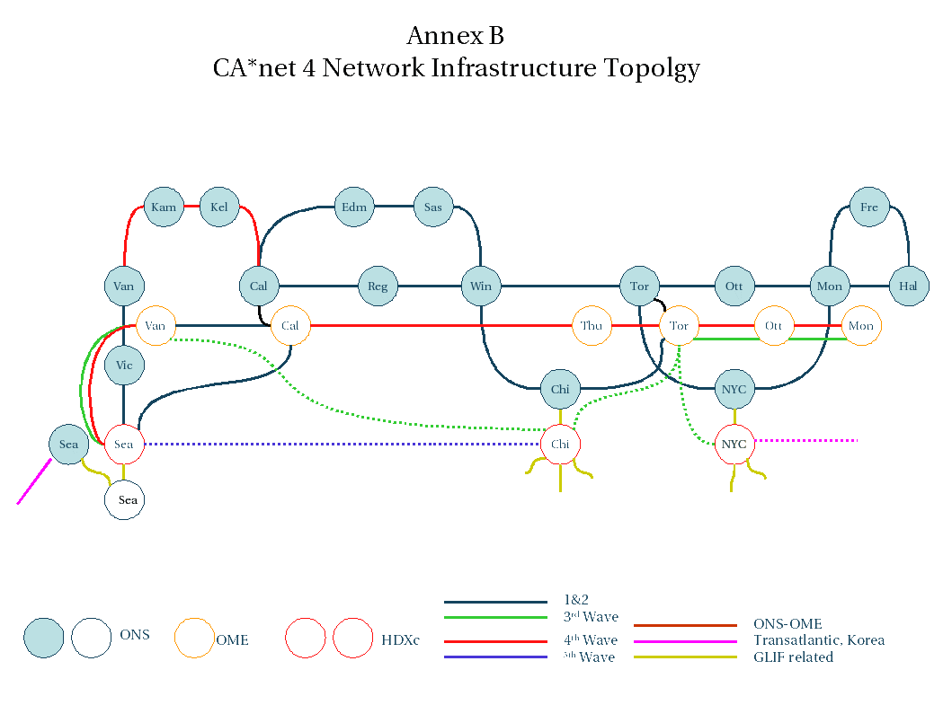

Annex C – CA*net 4 NOC OXC diagnostics

Link Layer diagnostics:
  - link status
  - received packets
  - recieved bytes
  - transmitted packets
  - transmitted bytes
  - recieved total errors
  - recieved FCS
  - recieved runts
  - recieved shorts
  - recieved jabbers
  - recieved giants
  - recieved PAUSE frames
  - transmitted PAUSE frames
  - recieved packets dropped due to interanl congestion
  - transmitted packets droppped due to internal congestion

SONET diagnostics:
- CV-S
- ES-S
- SES-S
- SEFS-S
- CV-L
- ES-L
- SES-L
- UAS-L
- FC-L
- PPJC-Pdet
- NPJC-Pdet
- PPJC-Pgen
- NPJC-Pgen

Annex D – Fault Management for WestGrid LightPaths

